1,kanban board : <https://github.com/nguyensjsu/cmpe202-liam-zhou/projects>

2,Project Journal link : <https://github.com/nguyensjsu/cmpe202-liam-zhou/blob/master/umlparser/README.md>

3,source code:

<https://github.com/nguyensjsu/cmpe202-liam-zhou/tree/master/umlparser>

4,screen shot

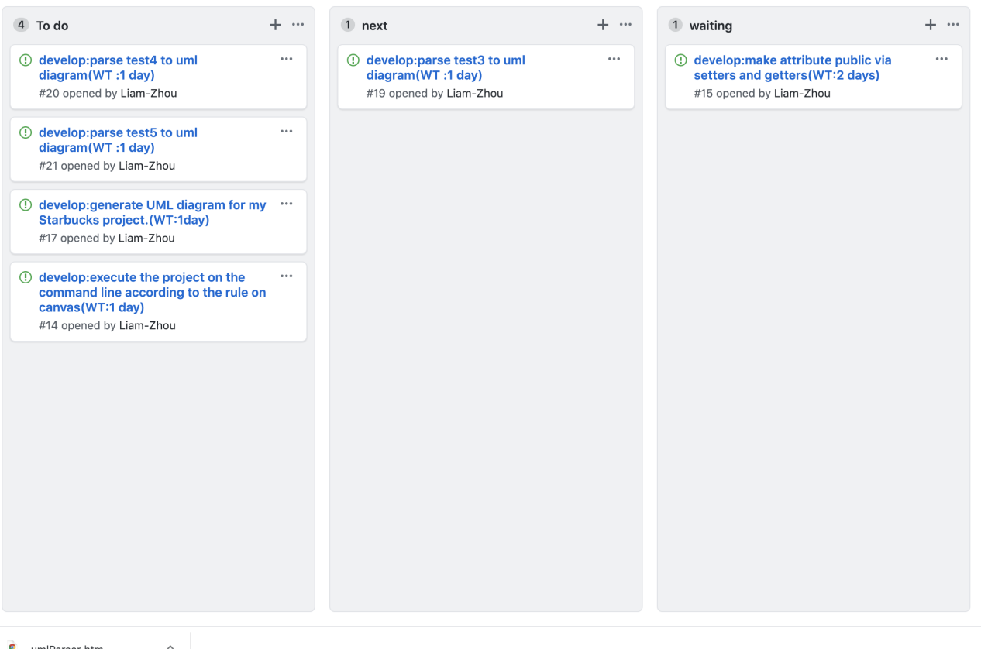

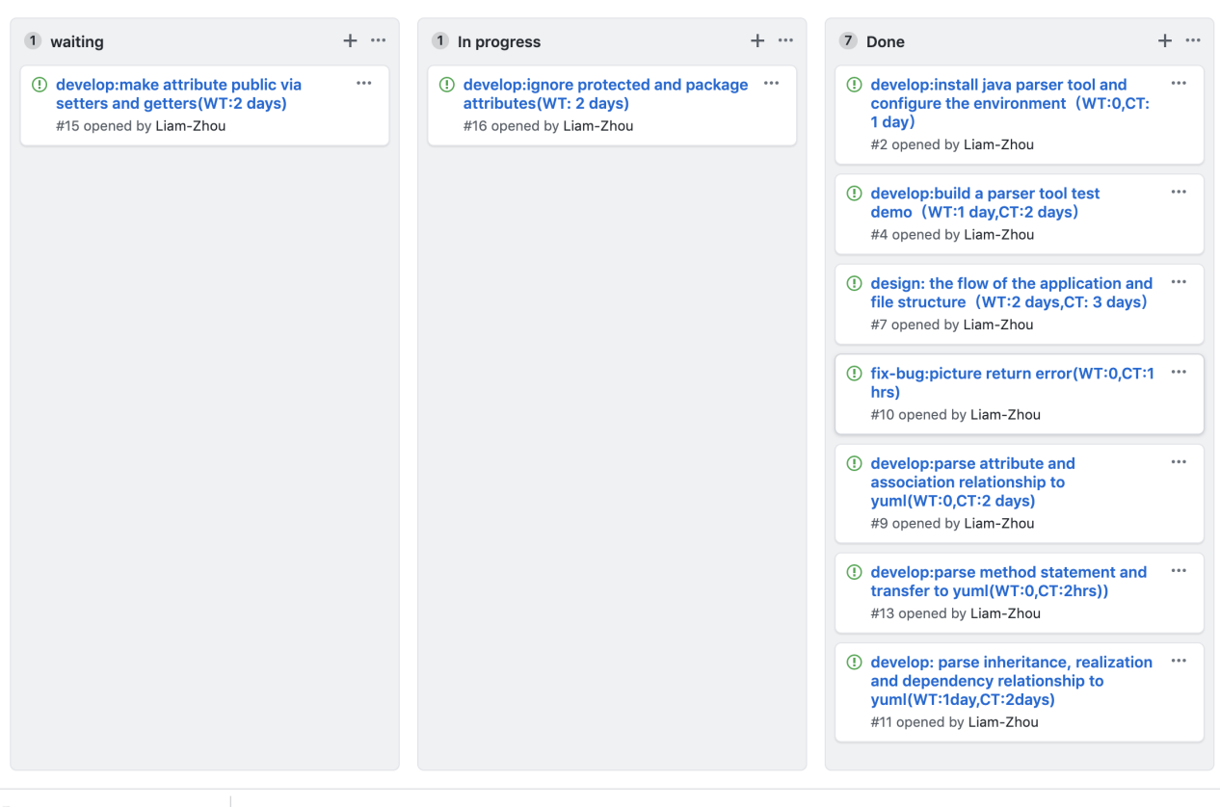

Week2:

1,kanban board : <https://github.com/nguyensjsu/cmpe202-liam-zhou/projects>

2,Project Journal link : <https://github.com/nguyensjsu/cmpe202-liam-zhou/blob/master/umlparser/README.md>

3,source code:

<https://github.com/nguyensjsu/cmpe202-liam-zhou/tree/master/umlparser>

4,screen shot

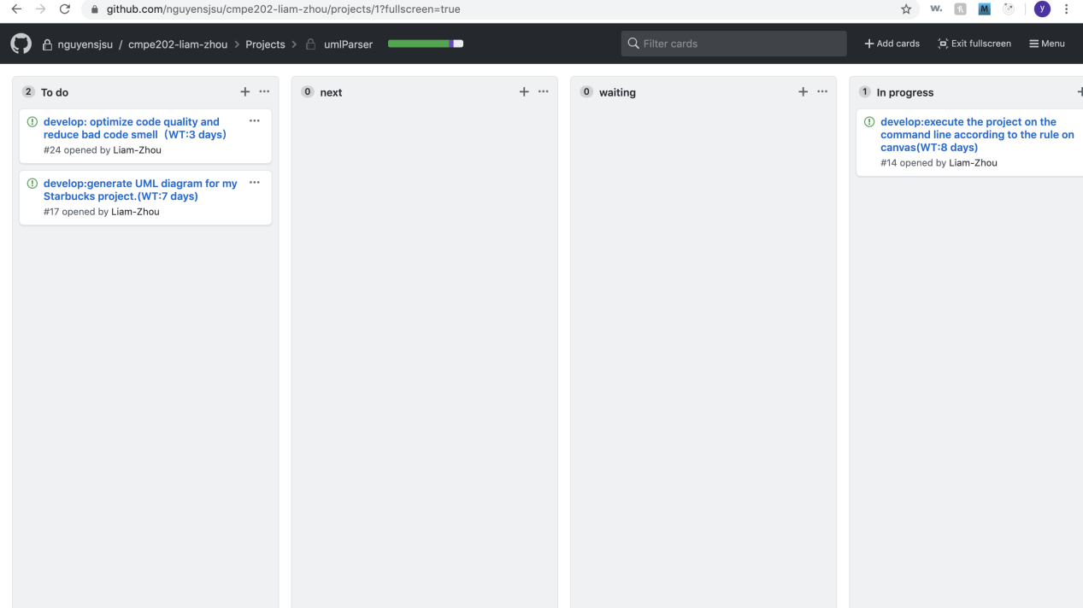

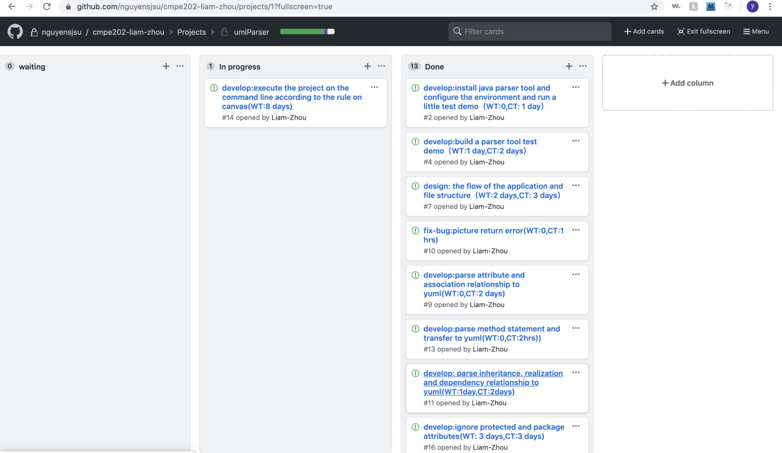

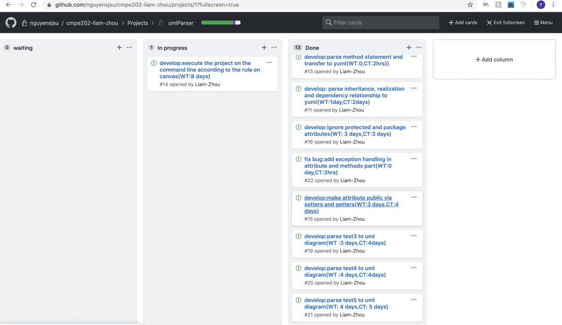

Week3:

1,kanban board : <https://github.com/nguyensjsu/cmpe202-liam-zhou/projects>

2,Project Journal link : <https://github.com/nguyensjsu/cmpe202-liam-zhou/blob/master/umlparser/README.md>

3,source code:

<https://github.com/nguyensjsu/cmpe202-liam-zhou/tree/master/umlparser>

4,screen shot

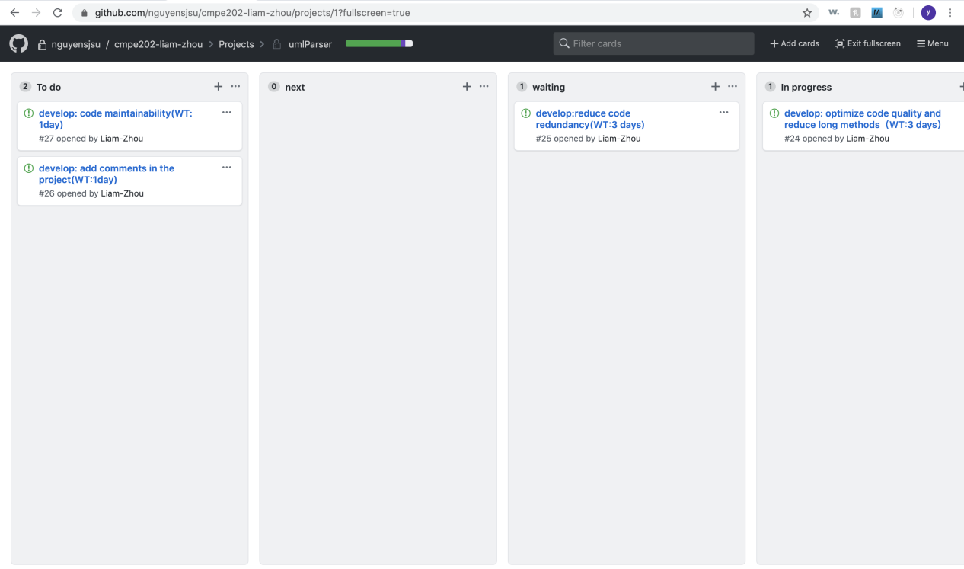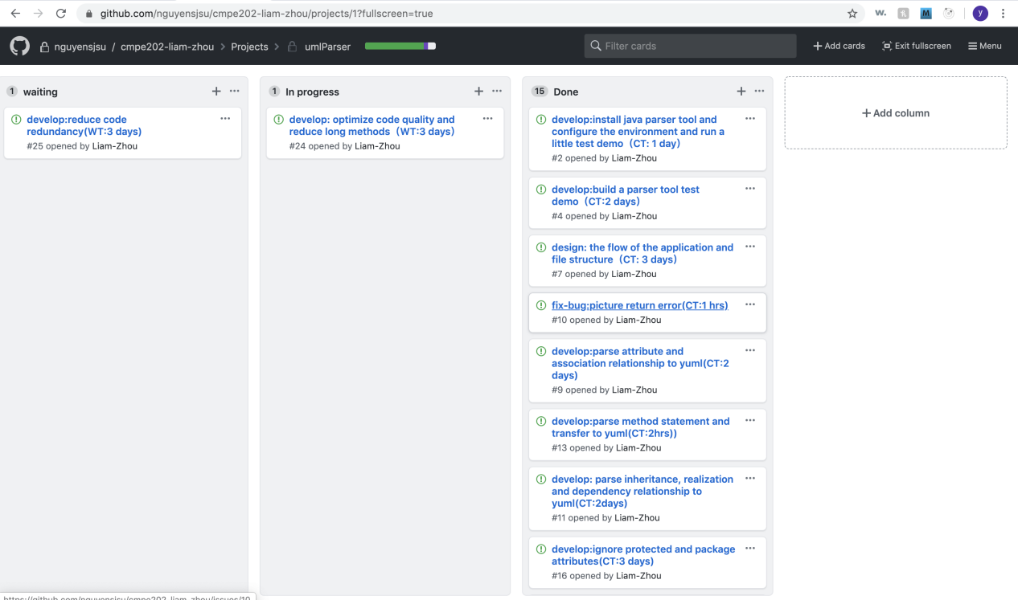

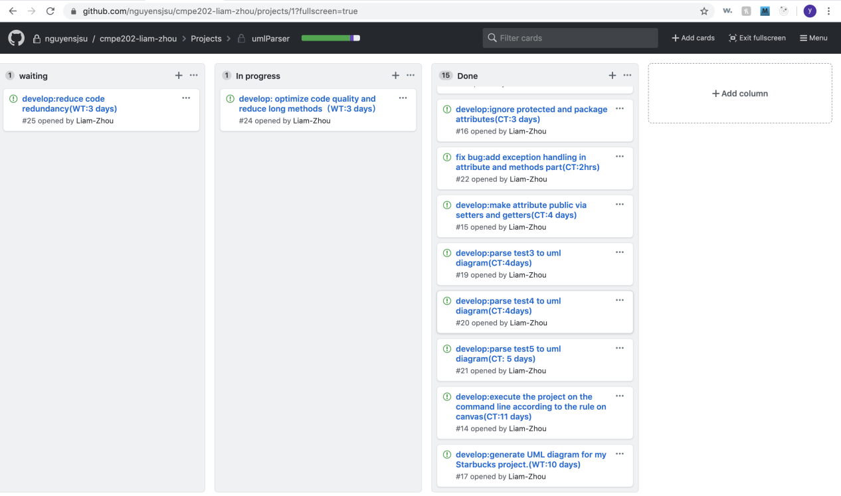

Week4

1,kanban board : [https://github.com/nguyensjsu/cmpe202-liam-zhou/projects (Links to an external site.)](https://github.com/nguyensjsu/cmpe202-liam-zhou/projects" \t "/Users/zhouyilin/Documents\\x/_blank)

2,Project Journal link : [https://github.com/nguyensjsu/cmpe202-liam-zhou/blob/master/umlparser/README.md (Links to an external site.)](https://github.com/nguyensjsu/cmpe202-liam-zhou/blob/master/umlparser/README.md" \t "/Users/zhouyilin/Documents\\x/_blank)

3,source code:

[https://github.com/nguyensjsu/cmpe202-liam-zhou/tree/master/umlparser (Links to an external site.)](https://github.com/nguyensjsu/cmpe202-liam-zhou/tree/master/umlparser" \t "/Users/zhouyilin/Documents\\x/_blank)

4,screen shot

